# EC2

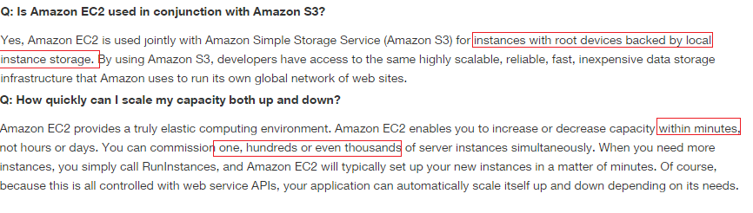

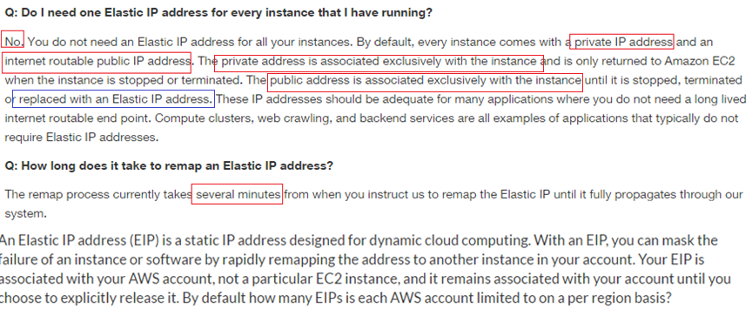

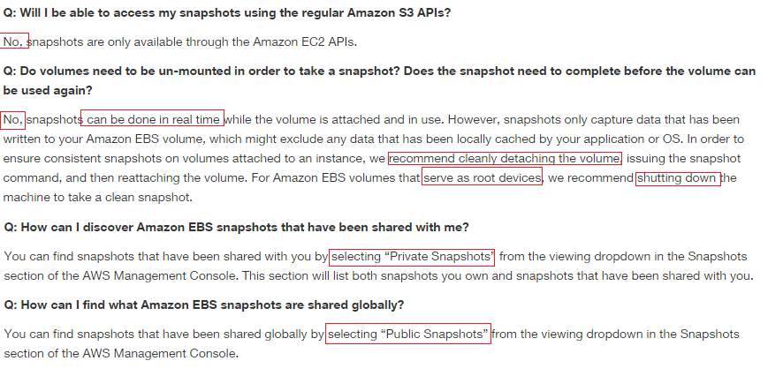

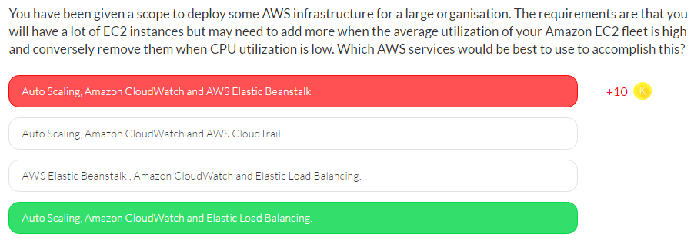

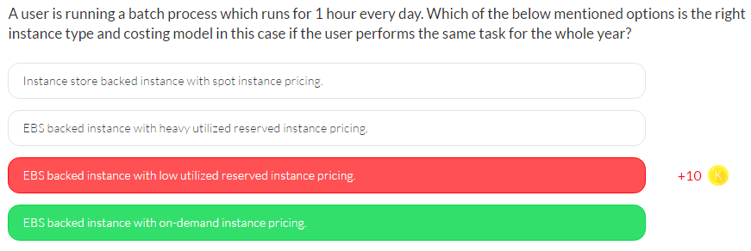

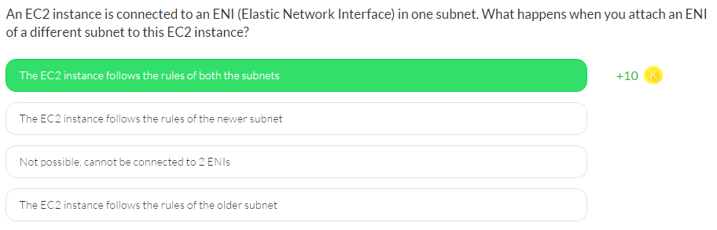

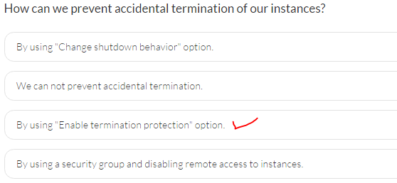

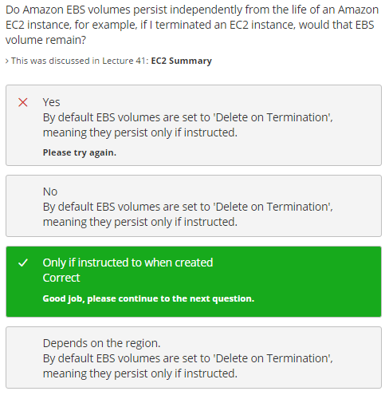

Set – “Delete On Terminate” flag to "N"

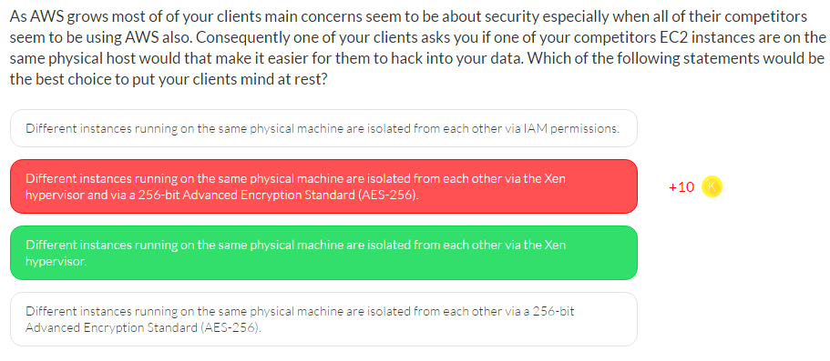

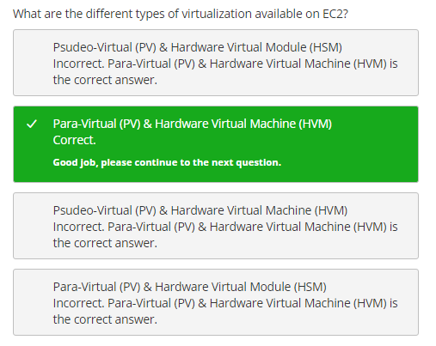

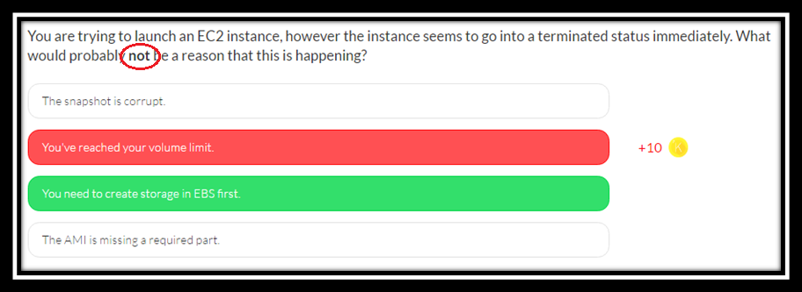

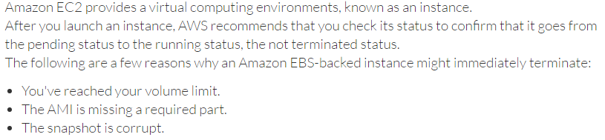

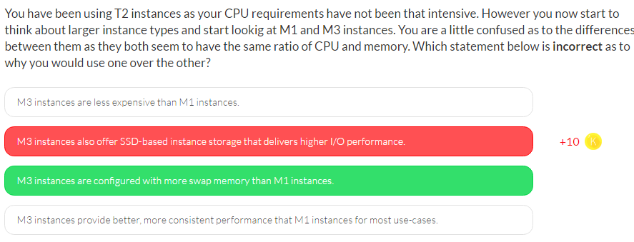

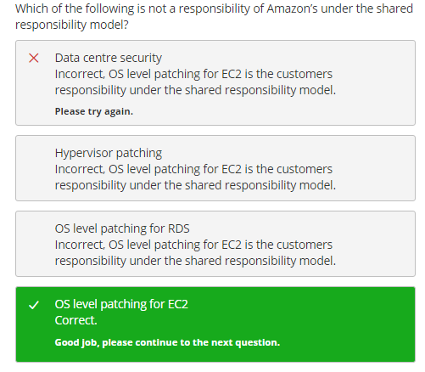

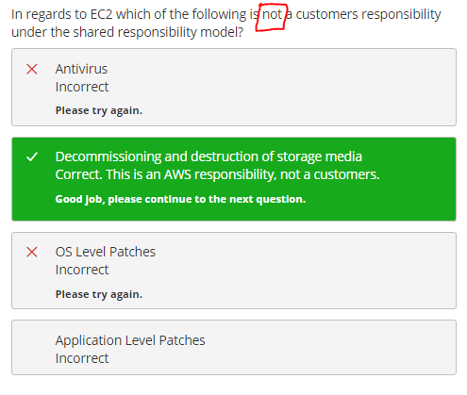

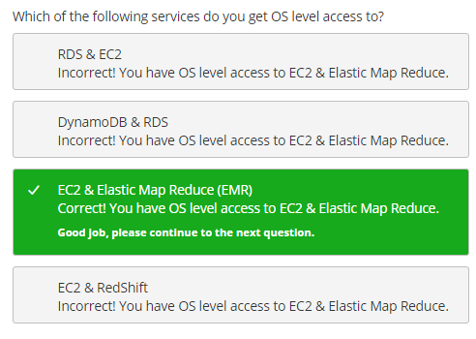

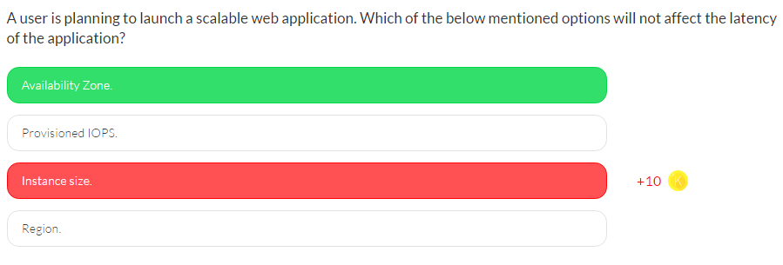

* In AWS, **the instance size decides the I/O characteristics**.
* The provisioned IOPS ensures higher throughput, and lower latency.
* The region does affect the latency; latency will always be less when the instance is near to the end user.
* Within a region the user uses any AZ and this does not affect the latency. The AZ is mainly for fault toleration or HA

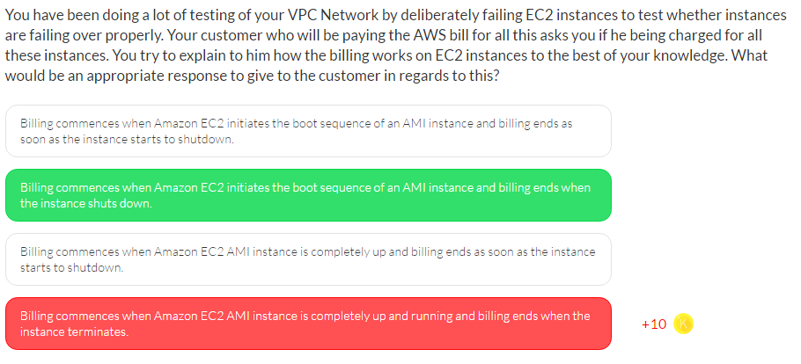

Billing commences when Amazon EC2 initiates the boot sequence of an AMI instance.

Billing ends when the instance terminates, which could occur through a web services command, by running “shutdown -h”, or through instance failure.

When you stop an instance, we shut it down but don't charge hourly usage for a stopped instance, or data transfer fees, but we do charge for the storage for any Amazon EBS volumes.

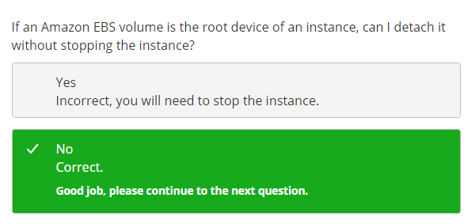

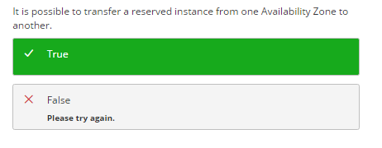

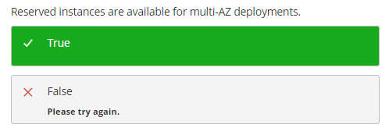

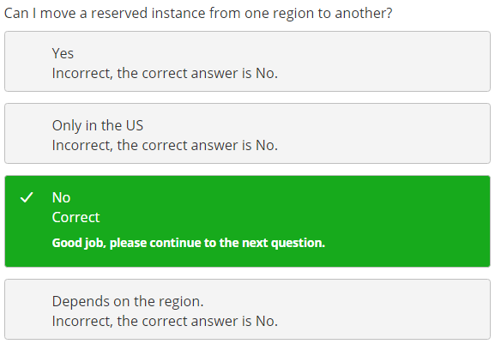

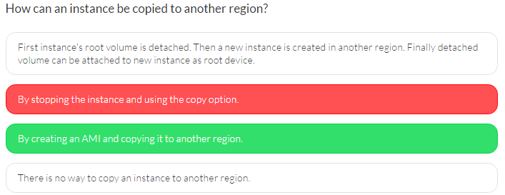

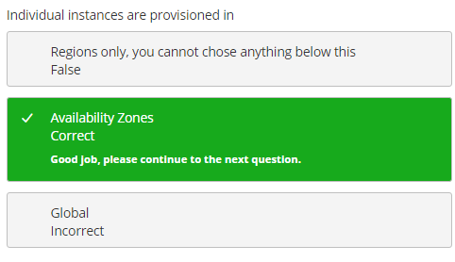

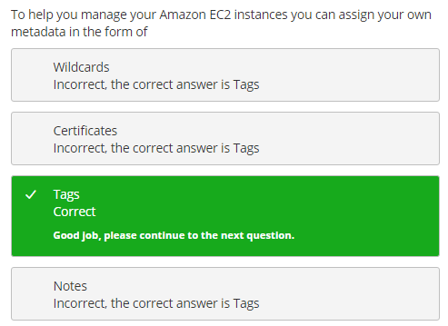

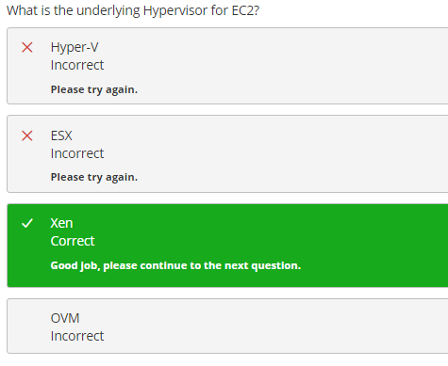

* Amazon EC2 uses a technology commonly known as virtualization to run multiple operating systems on a single physical machine.
* Virtualization ensures that each guest operating system receives its fair share of CPU time, memory, and I/O bandwidth to the local disk and to the network using a host operating system, sometimes known as a hypervisor.
* The hypervisor also isolates the guest operating systems from each other so that one guest cannot modify or otherwise interfere with another one on the same machine.
* AWS currently uses a highly customized version of the Xen hypervisor.

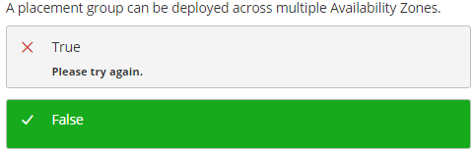

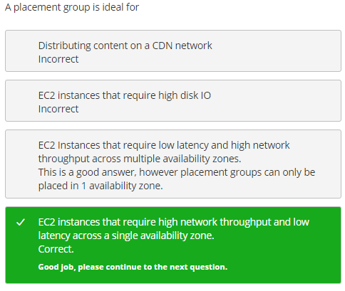

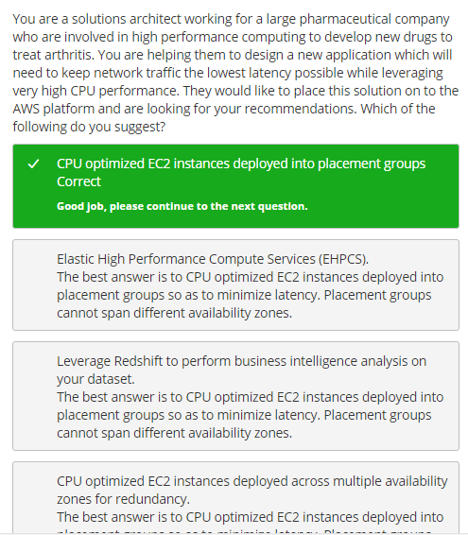

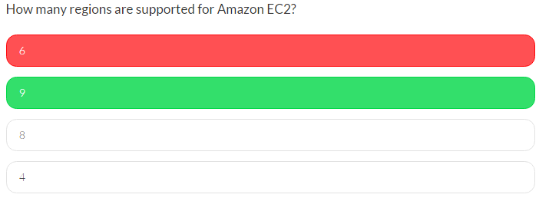

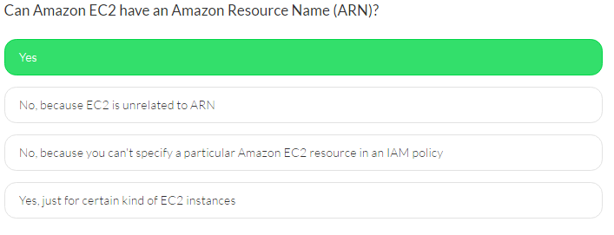

Amazon EC2 provides ARNs (Amazon Resource Names) to some of its resources, so you can specify in your IAM policies what specific resources can be affected by certain API actions that can be performed by authorized users.

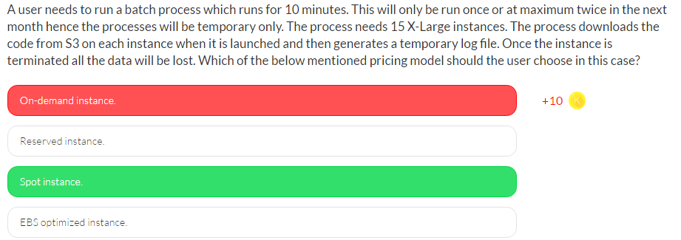

In Amazon Web Services, the **spot instance** is useful when the user wants to run a process temporarily. **The spot instance can terminate the instance if the other user outbids the existing bid**. In this case all storage is temporary and the data is not required to be persistent. Thus, the spot instance is a good option to save money.

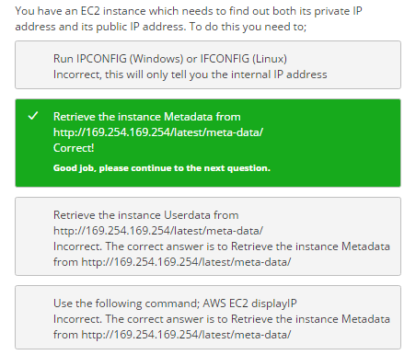

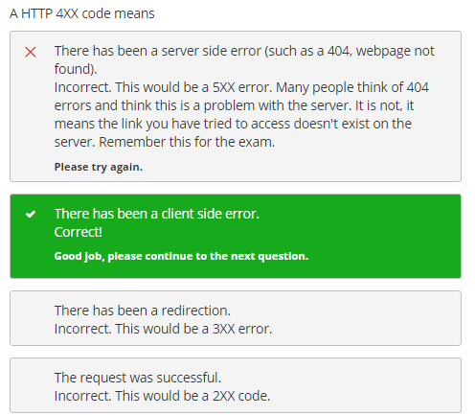

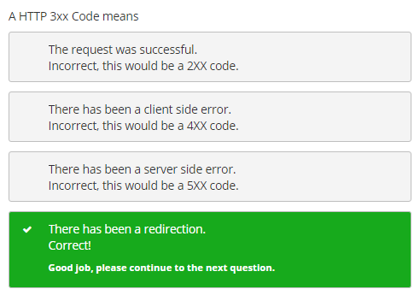

* Status codes are three-digit numbers.
* Code starts with a 1. These represent informational messages. These are rarely seen.
* Code starts with a 2, as in 200, that represents a successful response to the request.
* Code starts with a 3 in form 3xx represents a redirection response.
* Error codes at the 400 level mean there was a client-side error — think of something like the user typing the wrong URL in the address bar.
* Error codes at the 500 level mean there was a server-side error — think of something like the database server going down or perhaps running out of disk space.
* Five of the most popular error codes are 403, 404, 500, 503, and 504.

<https://www.globo.tech/learning-center/5-most-common-http-error-codes-explained/>

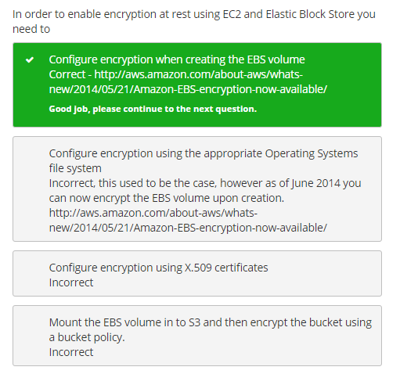

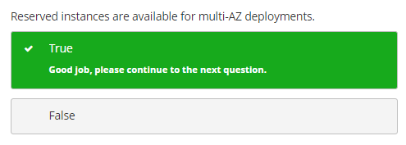

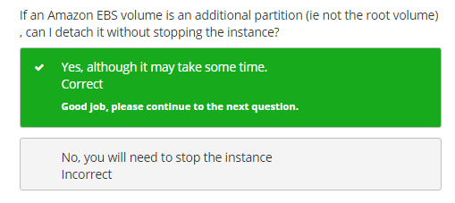

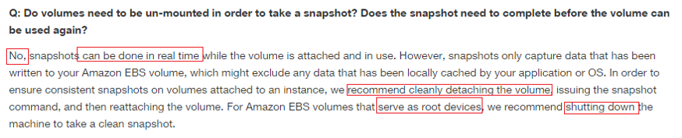

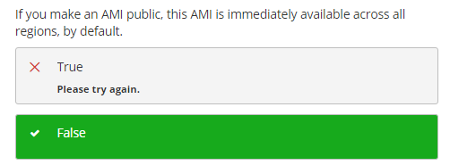

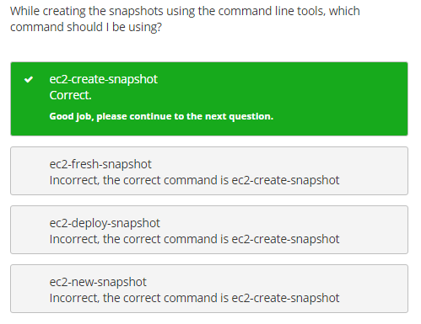

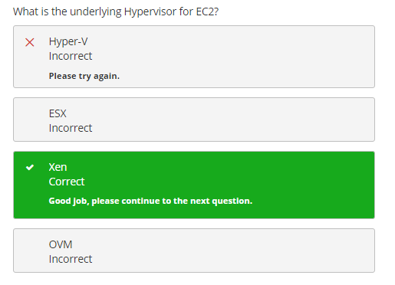

# Elastic Bean Stalk

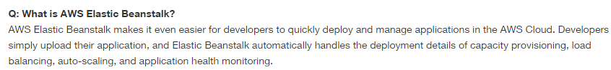

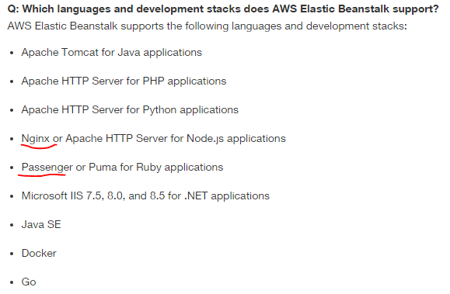

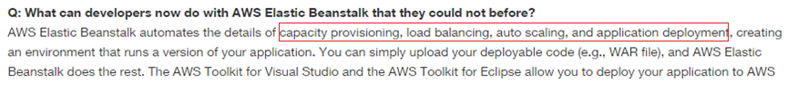

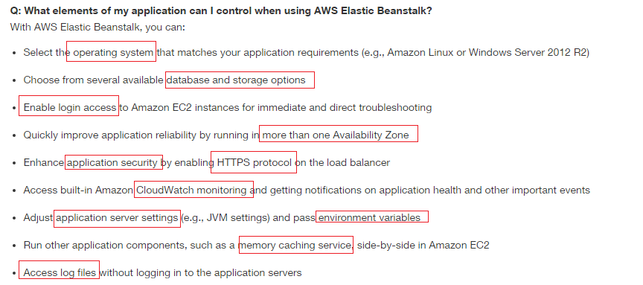

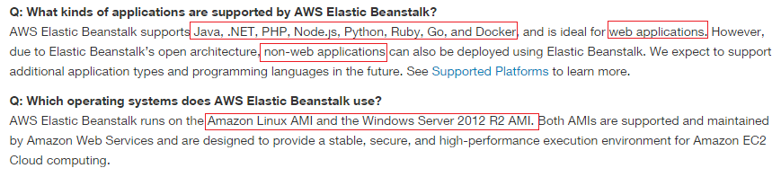

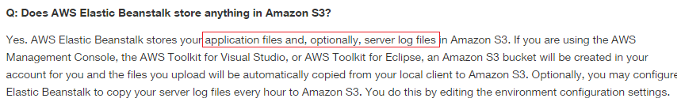

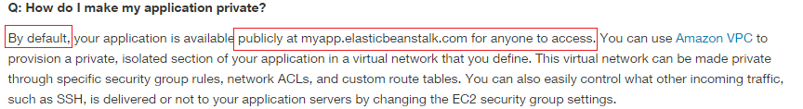

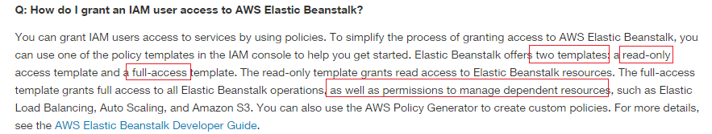

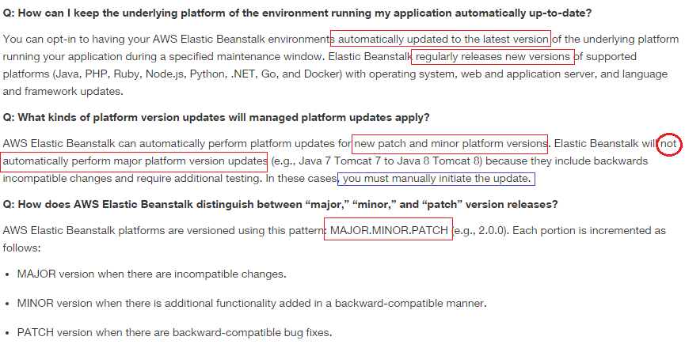

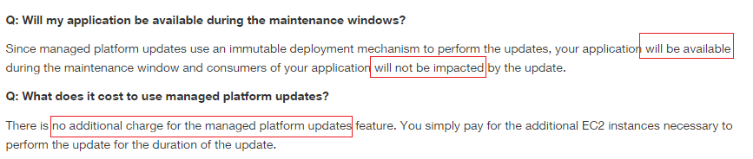

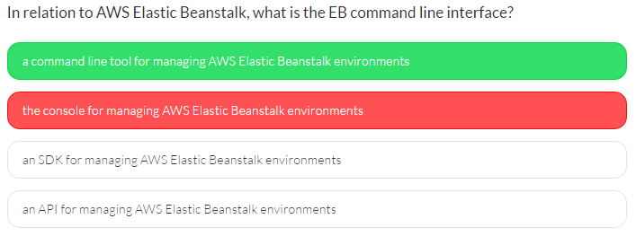

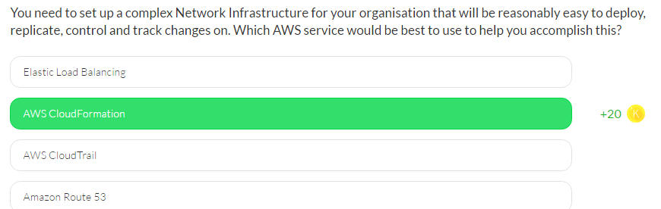

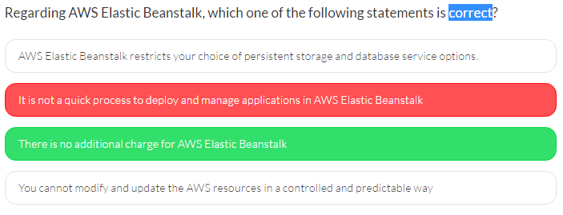

There is no additional charge for AWS Elastic Beanstalk;

You pay only for the underlying AWS resources that your application consumes.

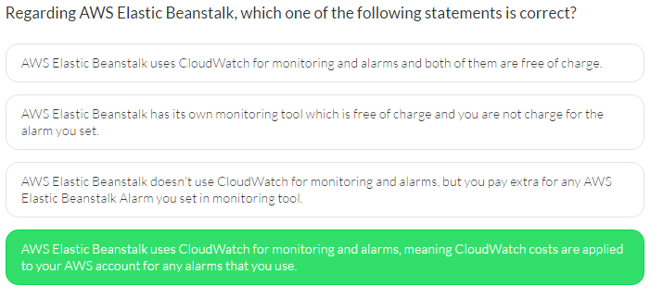

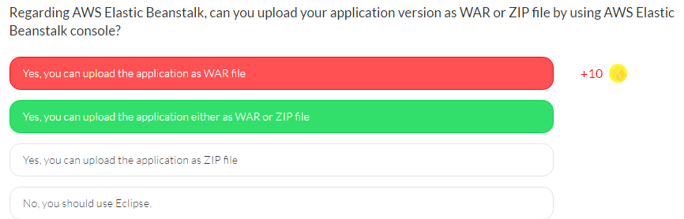

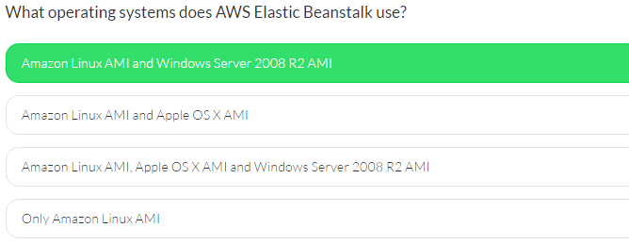

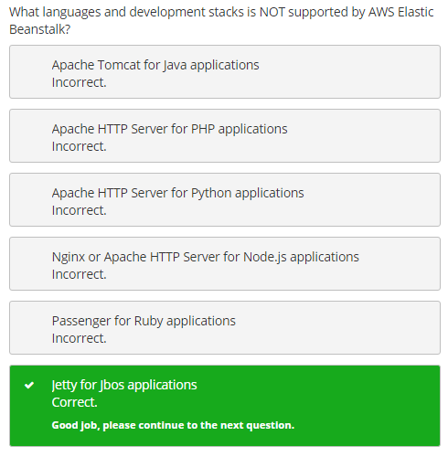

# Lambda

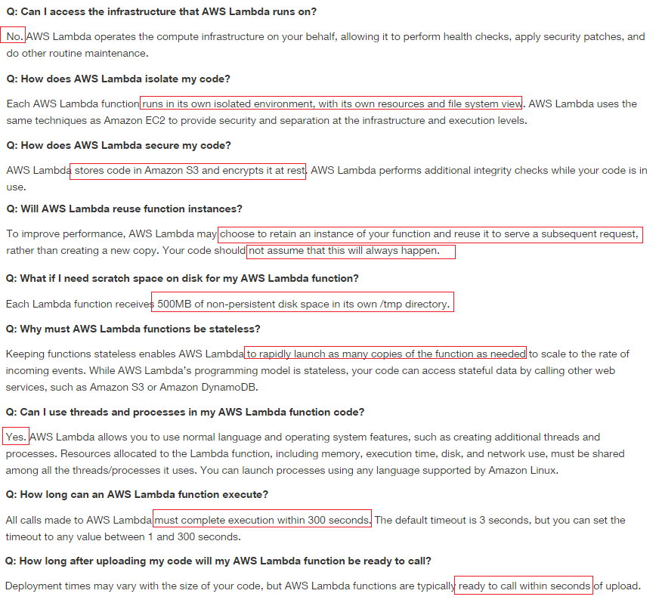

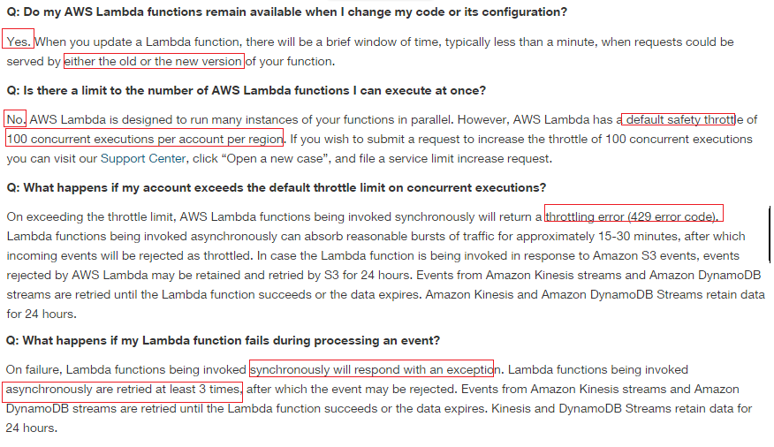

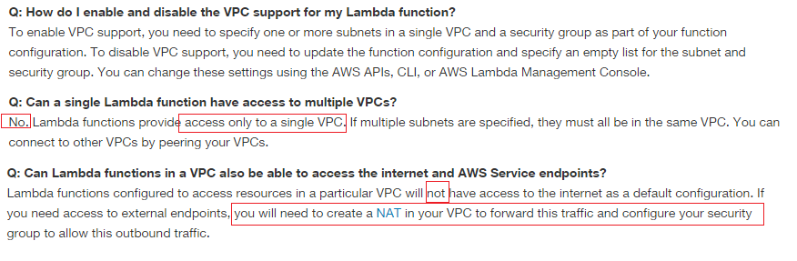

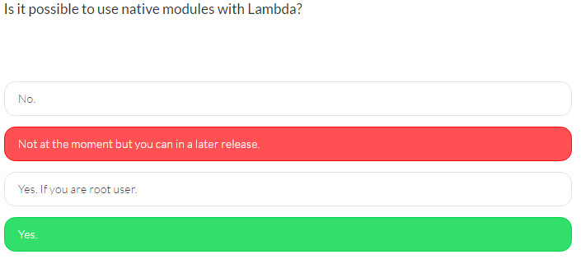

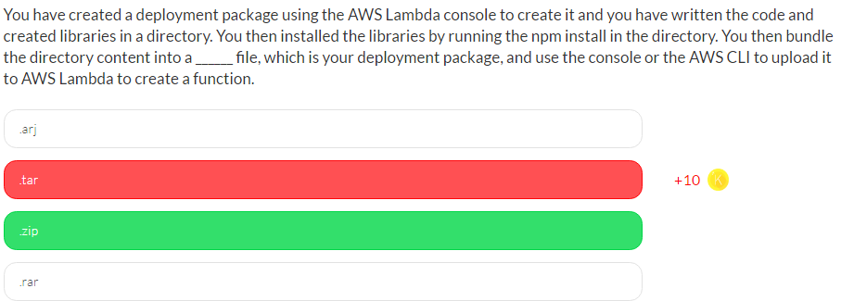

If you use the AWS Lambda console to create the deployment package, the console does all the work to bundle your code into a package. In advanced scenarios where your code requires additional libraries and other resources, you will need to create the deployment package.

To create a deployment package, you write code and create libraries in a directory. You install the libraries by running the npm install in the directory. You then bundle the directory content into a **.zip file**, which is your deployment package, and use the console or the AWS CLI to upload it to AWS Lambda to create a function.

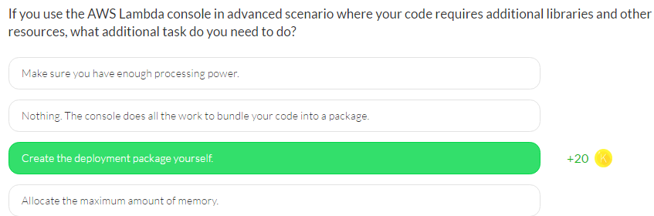

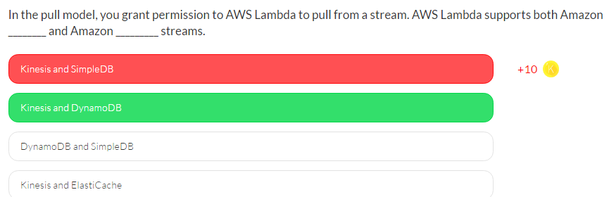

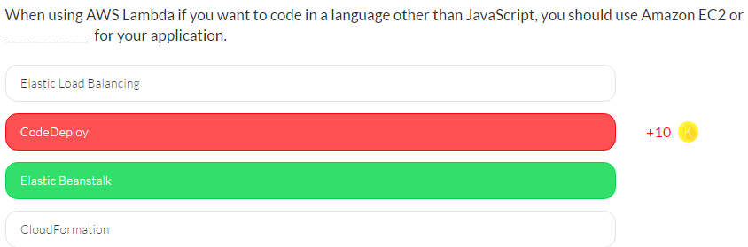

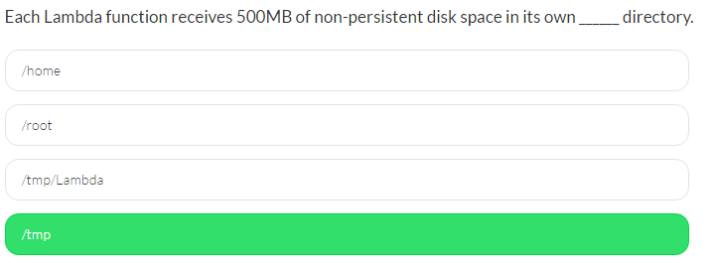

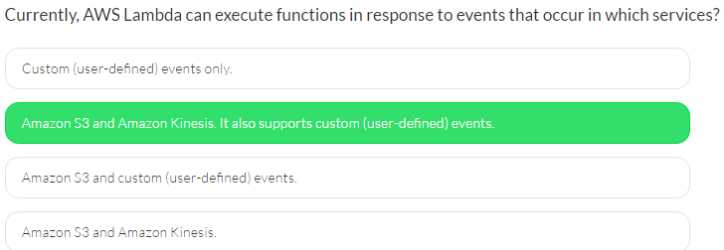

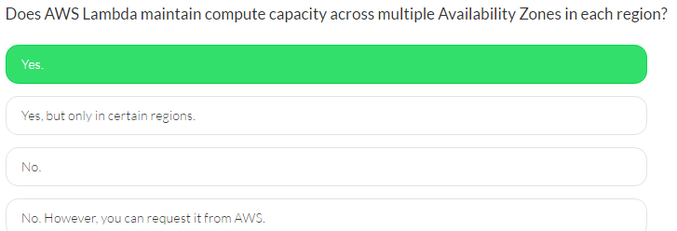

# Auto-Scaling

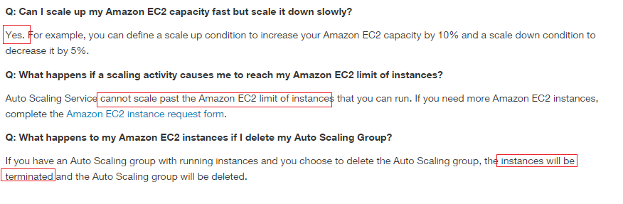



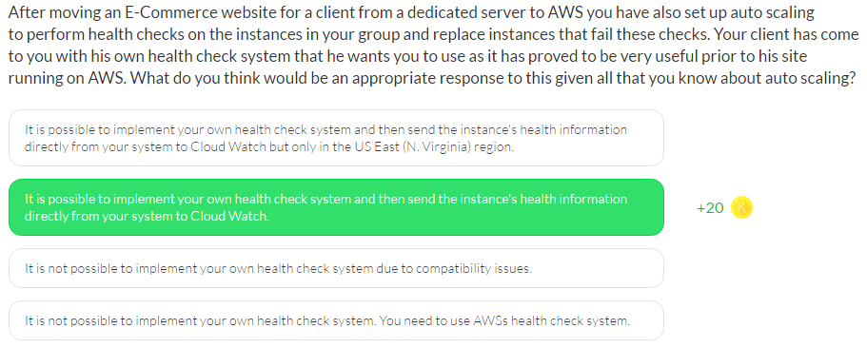

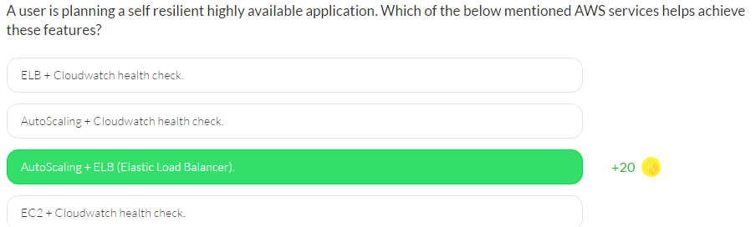

**ELB** performs a **health check on an instance at regular intervals**.

If any instance is unhealthy it will stop sending traffic to that instance.

**Auto Scaling** also performs an internal health check and

If any instance is unhealthy it will terminate and start a new instance.

This helps the user achieve self-resiliency and HA.

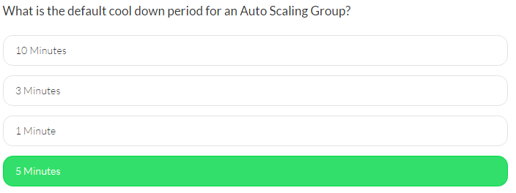

The default cool down period is 300 seconds.

Cool down is the wait period between the time a scaling activity ends and another scaling activity can start. It is associated with the Cloudwatch alarms.

During cool down the desired capacity cannot be modified by the Cloudwatch alarms.

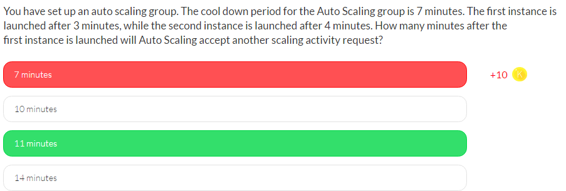

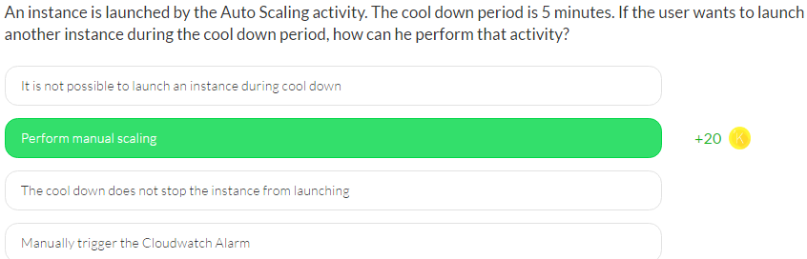

If the user wants to bypass the cool down period and perform scaling during that period, he can do manual scaling by changing the desired capacity. The only option that the user has to consider is to set the HonorCooldown flag to false.

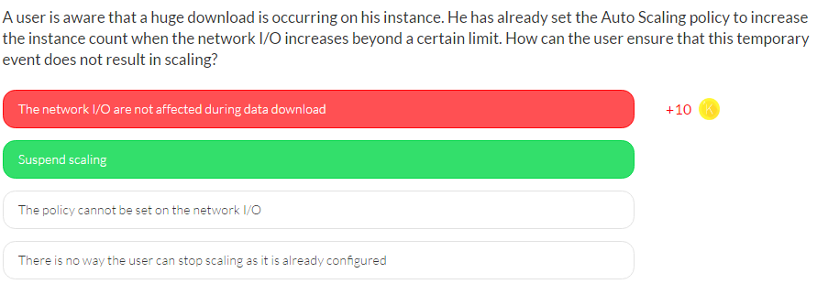

The user may want to stop the automated scaling processes on the Auto Scaling groups either to perform manual operations or during emergency situations. To perform this, the user can suspend one or more scaling processes at any time. Once it is completed, the user can resume all the suspended processes.

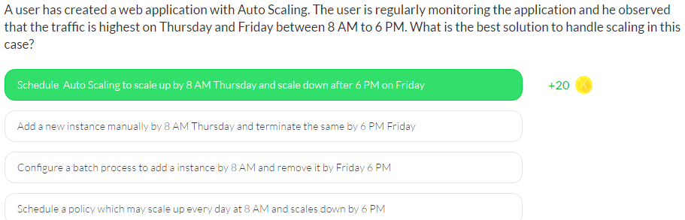

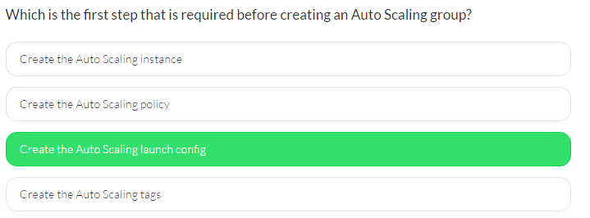

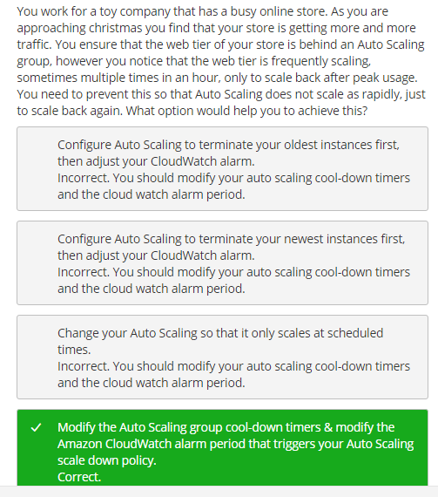

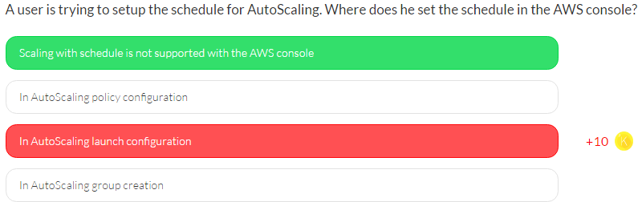

If the user wants to setup scaling with Schedule for AutoScaling, the user has to use CLI or Web Services. The AWS console does not support scaling with a schedule.

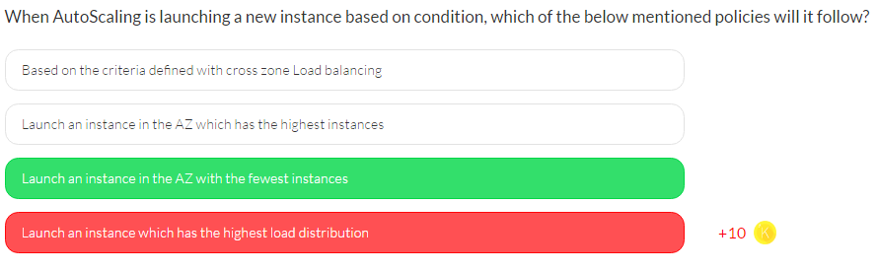

.

# Dev Ops

## EC2

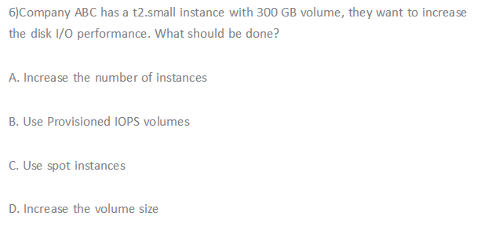

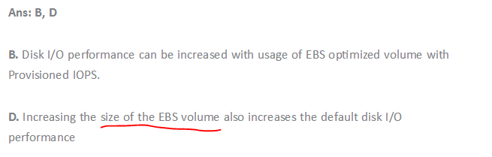

## AMI

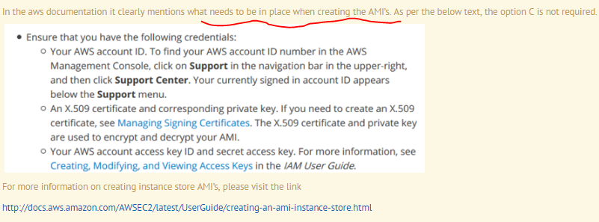

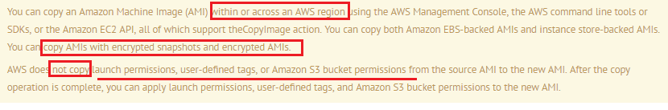

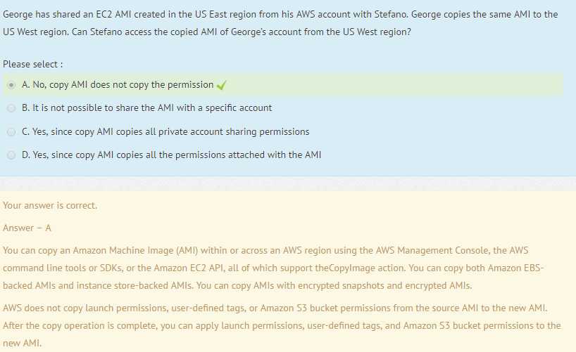

## ELB

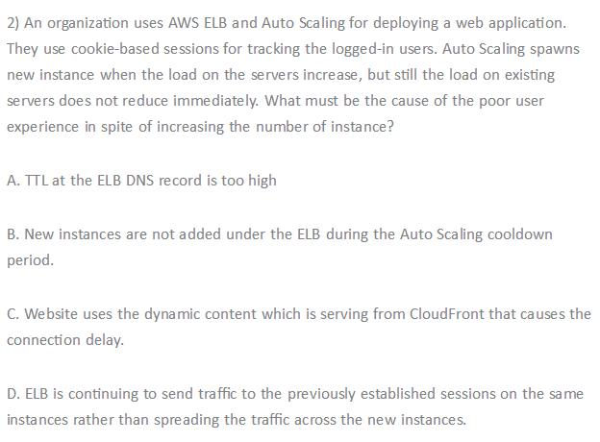

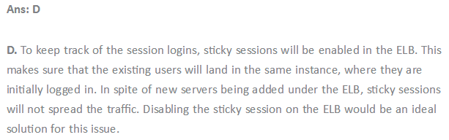

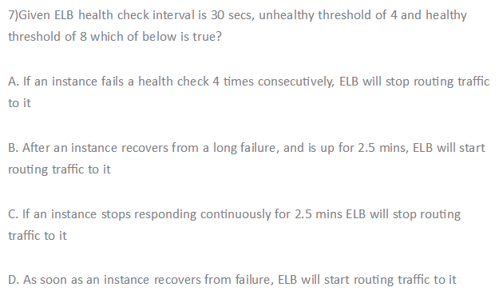

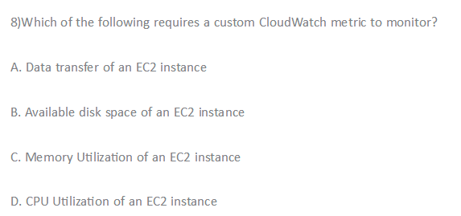

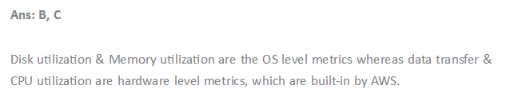

## Auto-Scaling

